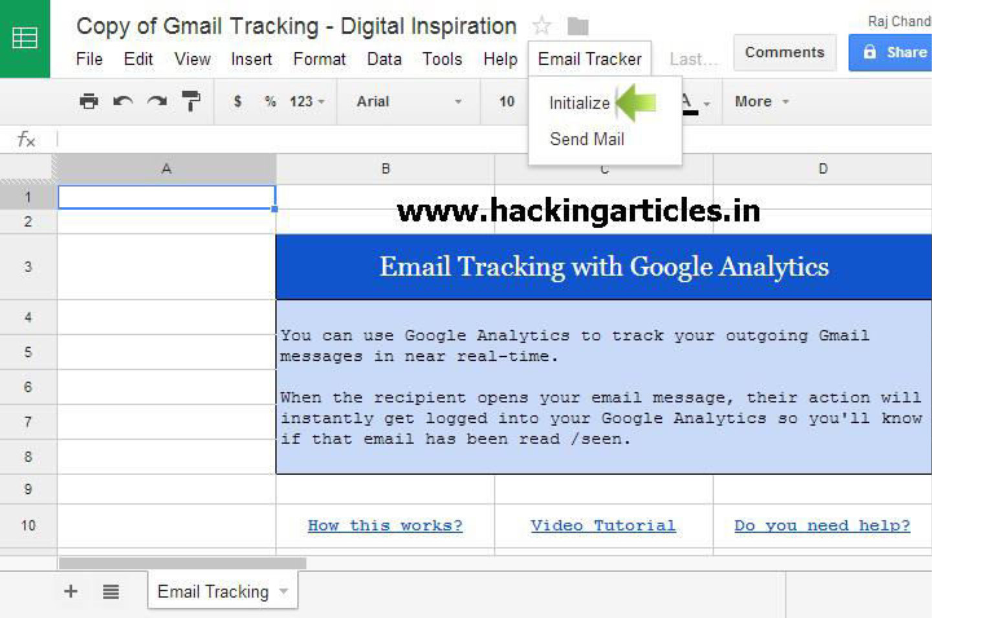

Email Hacking

How to Know when people open your email with Google Analytics

Open your Gmail account and compose your message and save in draft

Now open this **Google sheet** and choose the **Initialize** option under the **Email Tracker** menu

Now you’ll have to **authorize** the sheet to send your Gmail messages.

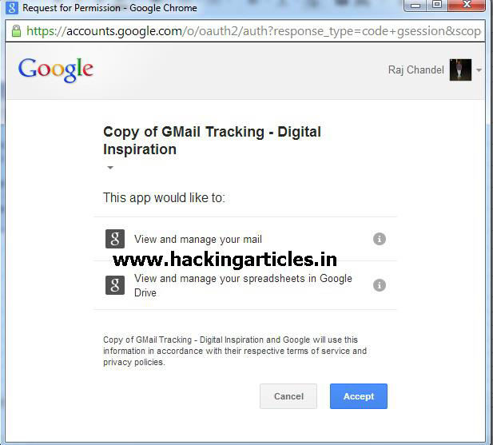

Once the script is authorized, choose **Email Tracker** -> **Send Mail**, select your Gmail draft from the drop-down, enter your Google Analytics Profile ID* and hit the Send button. Your mail will be delivered to the recipient.

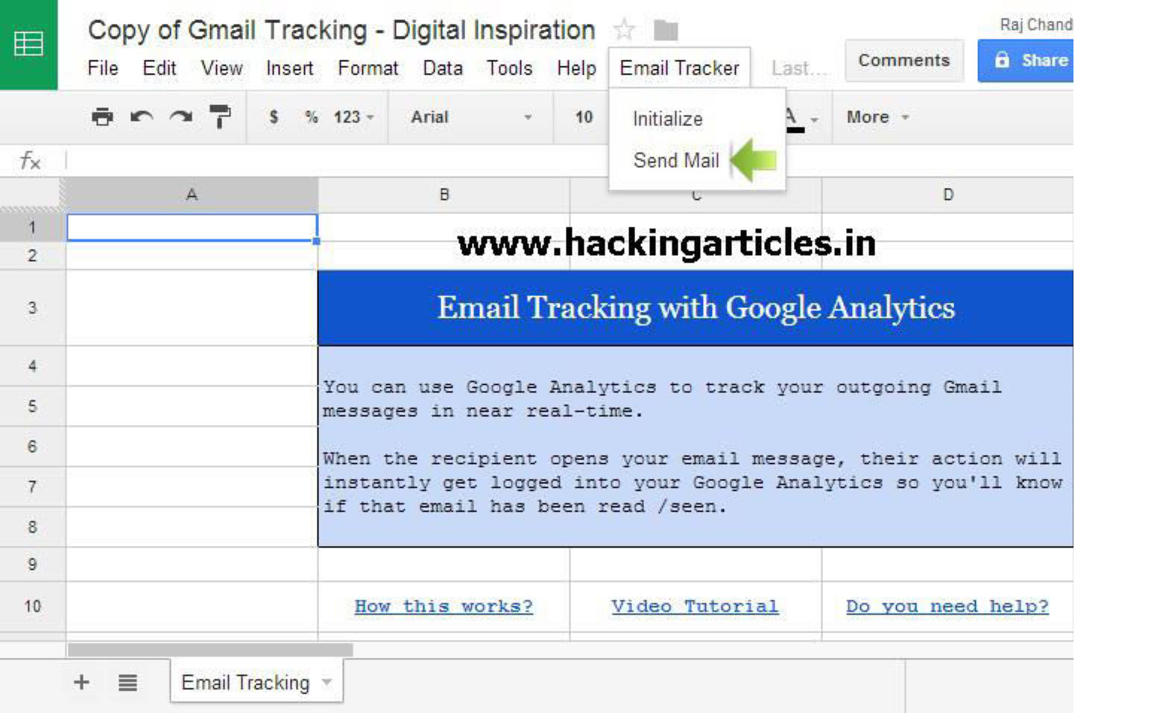

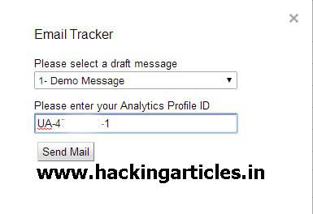

Now open **Google analytic** and find ***Events*** under the ***Standard Reports* group**

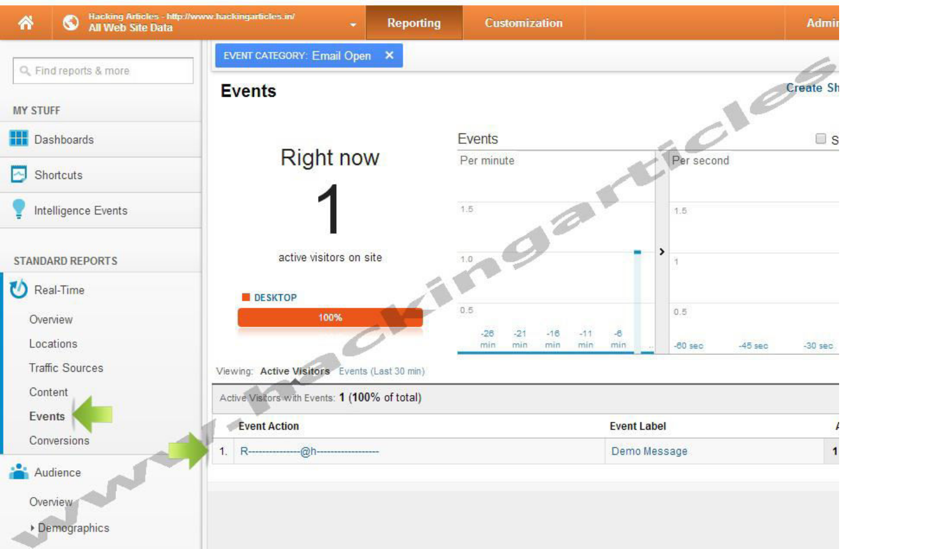

**Original Source:** [**http://www.labnol.org/**](http://www.labnol.org/)

Email spoofing: The story of “Congratulations you have won a lottery” like spam emails

posted in **EMAIL HACKING** on **JANUARY 7, 2014** by **RAJ CHANDEL** with **3**

**COMMENTS**

***Mail vs E-mail*** Back in old days when internet was not so common, we had to rely only on the postal/courier services. The only thing that bugs me about the traditional mail is their speed. This is when email comes. It offers numerous benefits, like its blazing fast, most of the time its free, you can attach from pictures to videos, from management point of view you don’t have to maintain a hard folder, last but not least its environment friendly. In short, email is one of the greatest inventions of all time.

***What is a spam?***

I’m not that old, but again back in those dial-up connection days, there was no such thing as Gmail, most of people either used Hotmail or Yahoo mail for the emails. The problem with these two email service providers is the spams. Spams are irrelevant emails coming to you, mostly used for marketing a product/service, but they are cases where spam emails have hacked a person

through social engineering attack or session hijacking. Phishing is also associated with spoofed emails, phishing is “*the fraudulent practice of sending emails purporting to be from reputable companies in order to induce individuals to reveal personal information, such as passwords and credit card numbers*“.

If you only use Gmail, you are a lucky person, because Google has got some very intelligent and sophisticated spam filtering mechanism. And frankly speaking I don’t get spams at all in my Gmail, but in case of Ymail or Hotmail … let’s just not talk about it.

***What is e-mail spoofing?***

In today’s article I will focus on Email spoofing. So, the first question you may ask is what is spoofing? Spoofing in simple terms is when Alice tries to be Bob. Email spoofing is when Alice sends an email to Eve but she keeps her identity to be Bob. When Eve receives an email she thinks that Bob has sent the email but it’s not.

*PLEASE NOTE THIS TUTORIAL IS FOR EDUCATIONAL PURPOSES ONLY. GENERATING SPOOFED EMAILS OR SPAM IS ILLEGAL AND PUNISHABLE UNDER THE LAW. YOU WILL BE RESPONSIBLE FOR YOUR ACTIONS.*

***Platform:*** Windows 7 (also works on MAC and Linux)

***How to spoof an e-mail ?***

There can be different ways of spoofing an email, but I am going to use “sendmail” program for it. Sendmail is a simple command line program used to send emails via SMTP protocol.

1. Go to Google and type “sendmail google code”. Open the page highlighted below.

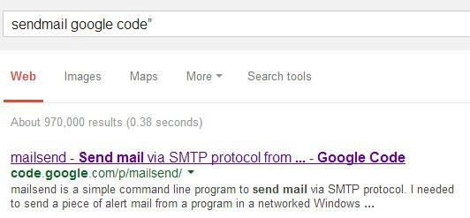

2. This is what sendmail on google code looks like.

3. Go to the download section and download the appropriate file, as I m on windows so, I will be downloading the “.exe” file.

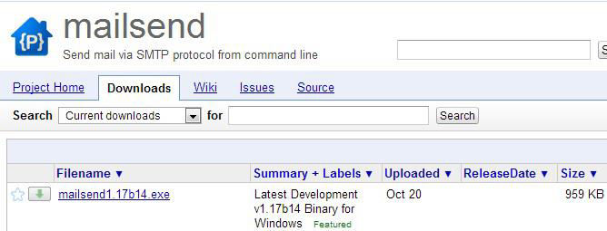

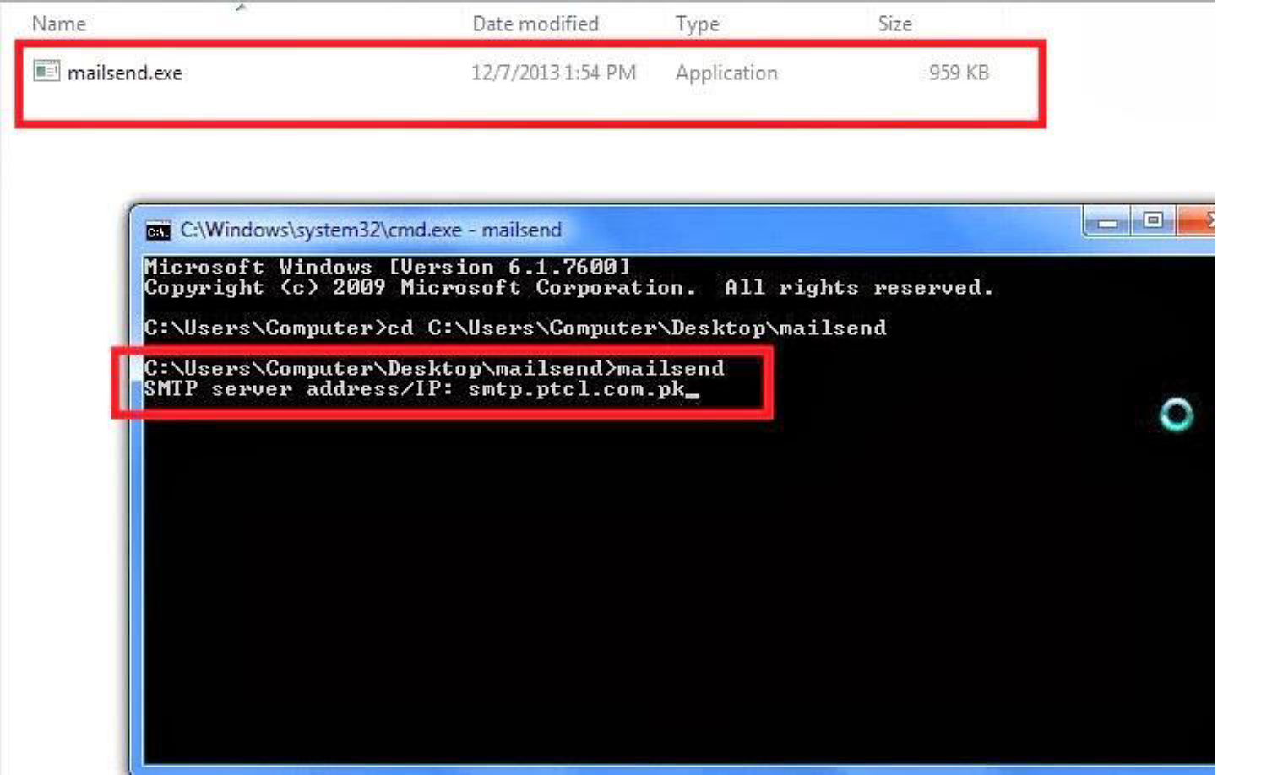

Open the command line and call the program “mailsend”. As soon as you type mailsend, the first thing it will ask for is SMTP server. This is a very critical part, if you don’t provide the right SMTP server your email will not be sent. You have to chose a SMTP server that doesn’t require authentication. I will be using PTCL’s SMTP server i.e “smtp.ptcl.com.pk“, this server runs on port 25.

Next in “from”, enter the email ID of the person you want to spoof, In this case I m making a spoof email of Bill Gates i.e [“billgates@microsoft.com](mailto:billgates@microsoft.com)“

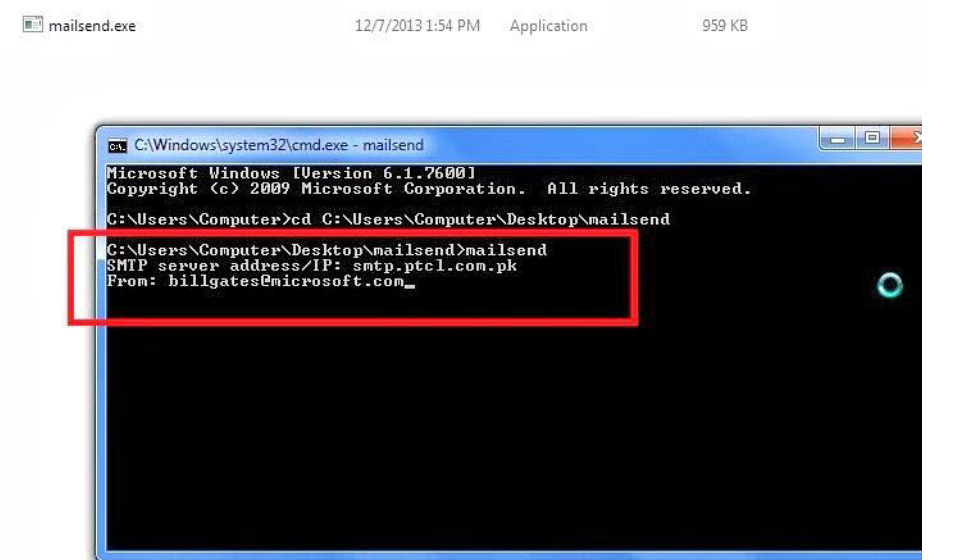

Provide the email id of receiver, I m giving my own email id.

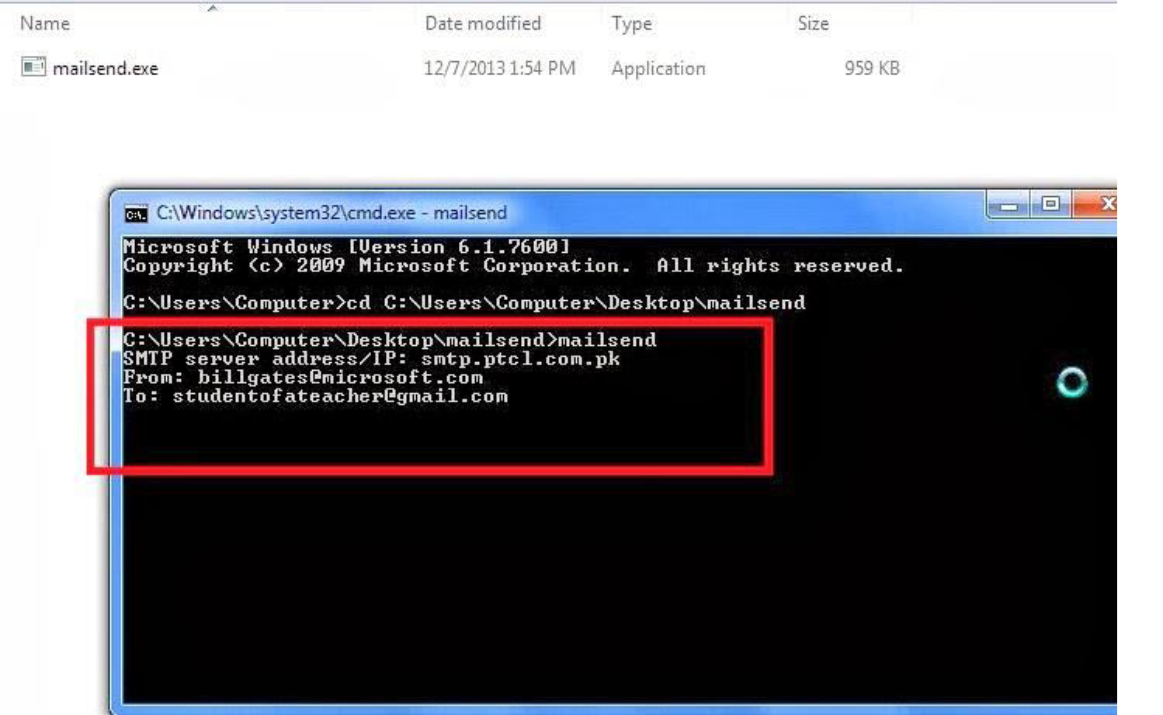

Enter subject and then write your message, after you have completed your message.

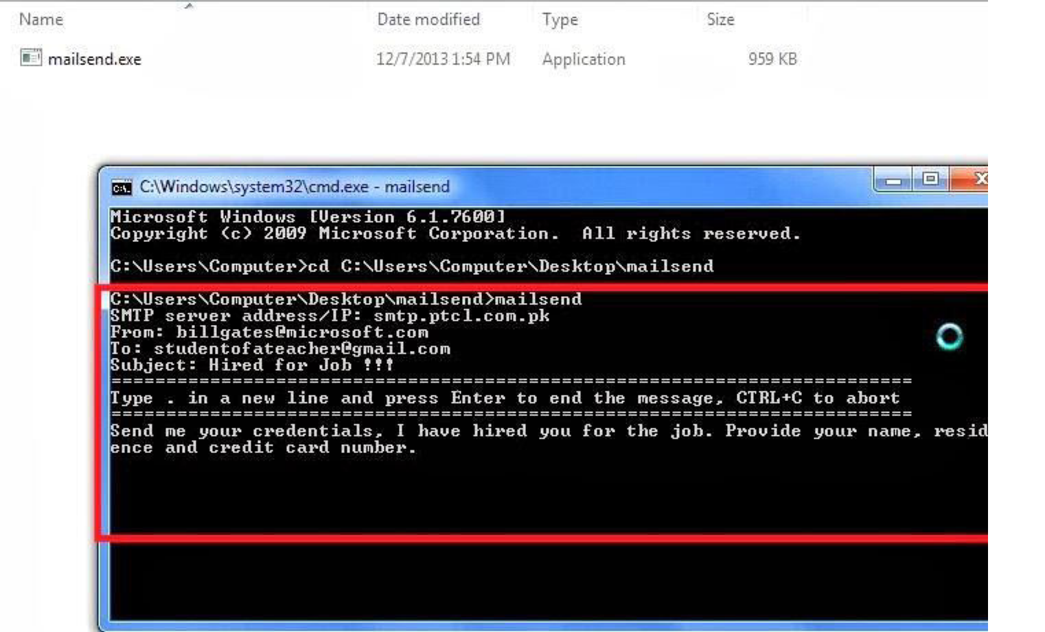

Press enter, then press dot button and again press enter, a message will pop that your email has been sent.

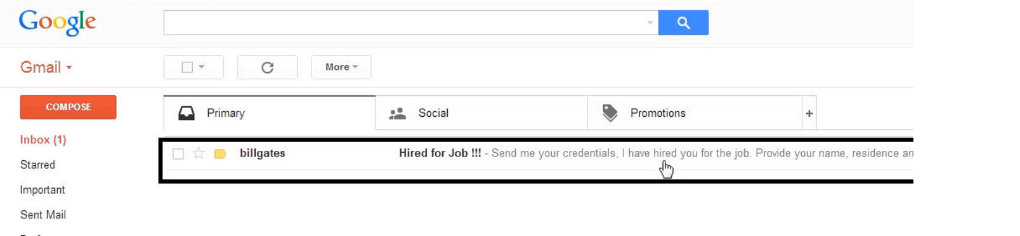

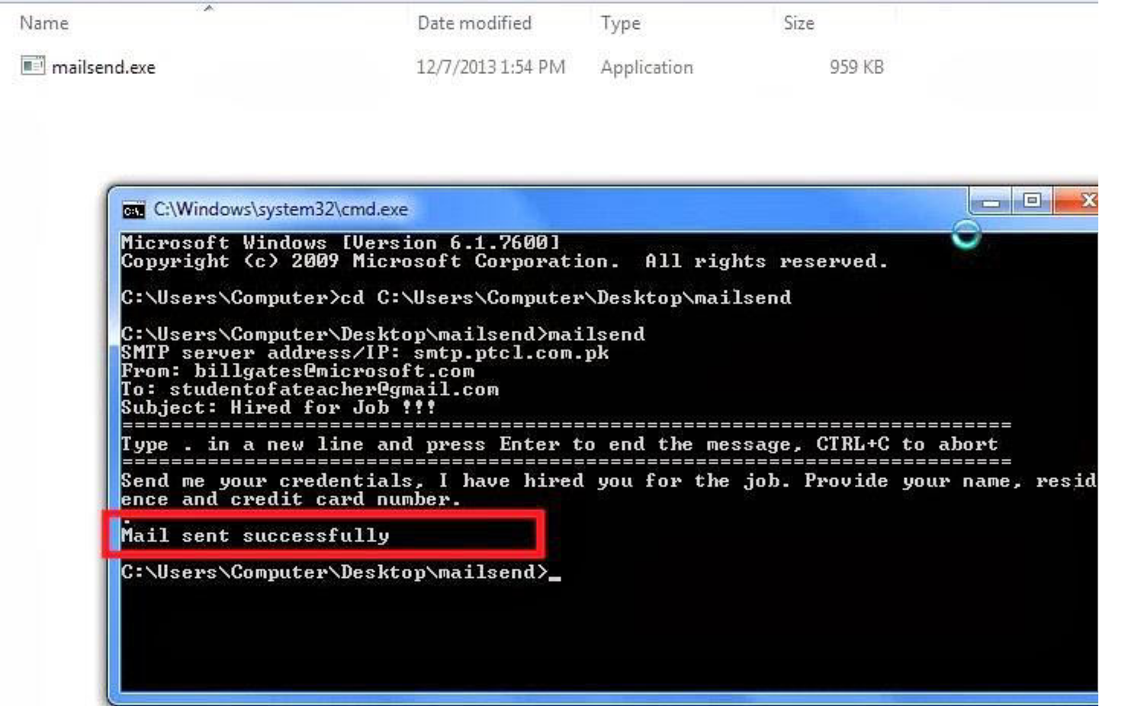

Here you can see my inbox has got that spoofed email.

Inbox overview.

**Author**: This Article Written by Fowz Masood who has completed his bachelor’s in Electrical Engineering (Comp Engg) He is pursuing a master’s degree in Computer Communications and Security from SEECS-NUST, Pakistan. He has wide variety of interests Computer security/Network security

**Blog**: “https://grumpygeekwrites.wordpress.com

**You might also like:**

How to Protect Email ID From Spam

Email Tracking Tools

Search Gmail emails without login Gmail

How to Transfer Email one Account to another Account

Revolution of Email

How to Send Encrypted Mail through Gmail (Secure Gmail by

Streak)

Linkwithin

posted in **EMAIL HACKING** on **DECEMBER 14, 2013** by **RAJ CHANDEL** with **0**

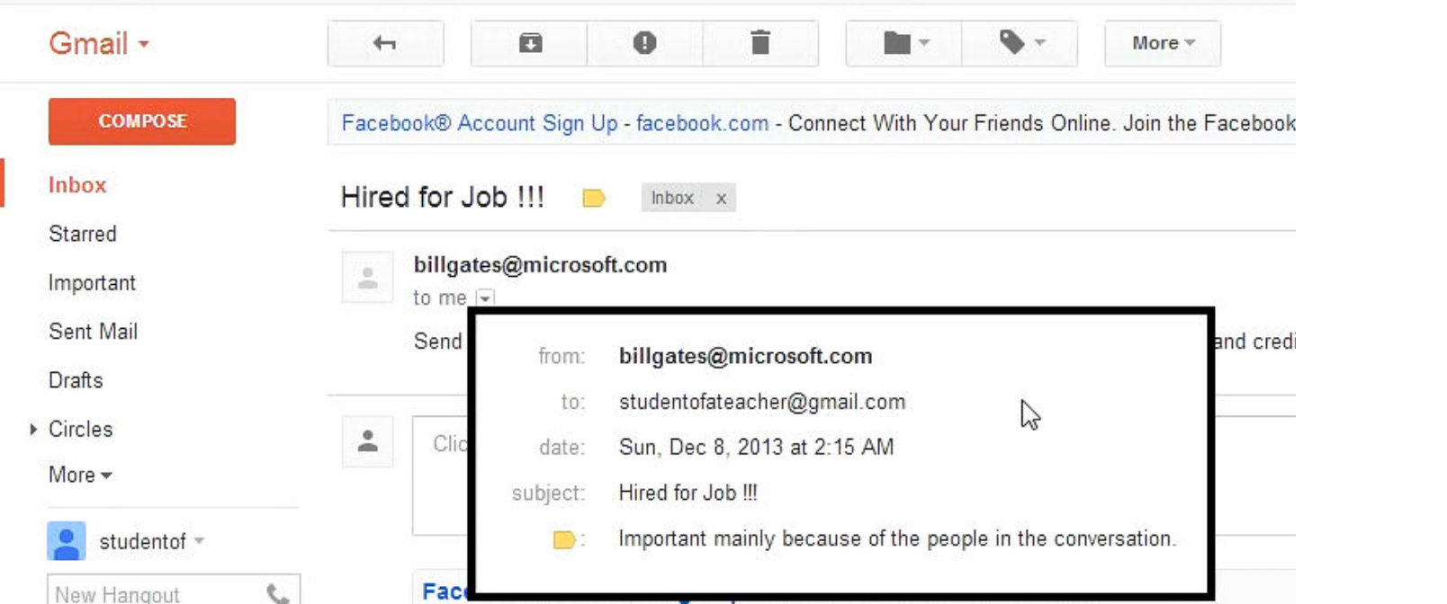

**COMMENT**

Secure Gmail encrypts and decrypts emails you send in Gmail. This happens all on your machine, and the unencrypted text never reaches Google servers. This is useful if you don’t want anyone but the intended recipient to ever read your email (i.e. companies, governments, etc.)

First Install Secure **Gmail by Streak plugin** in your chrome browser from **here**

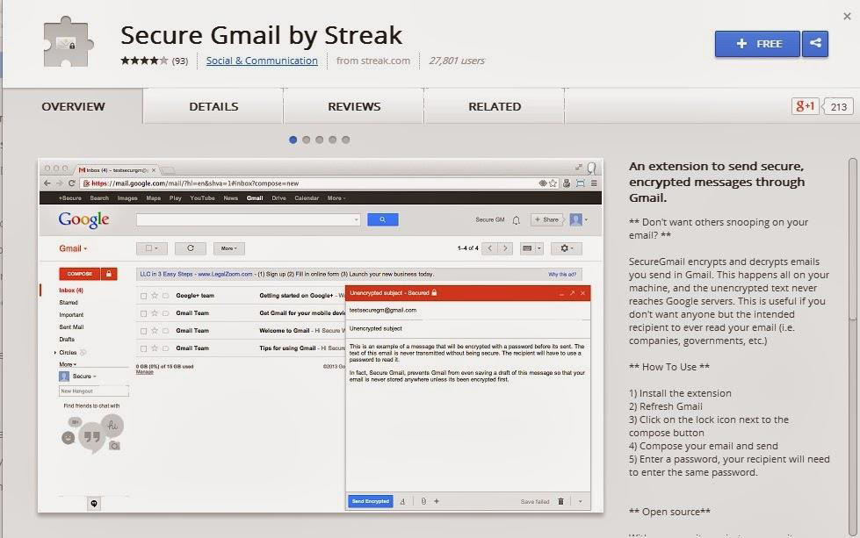

Now refresh your Gmail Click on the lock icon next to the compose button.

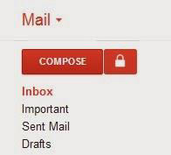

Compose your email and send

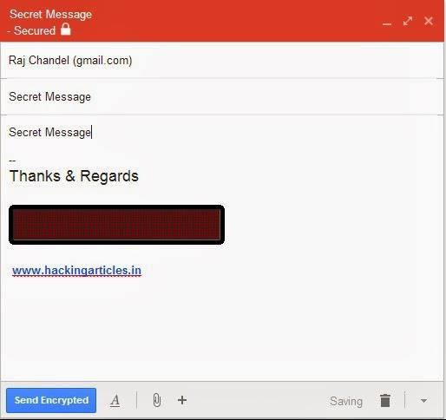

Enter a password; your recipient will need to enter the same password.

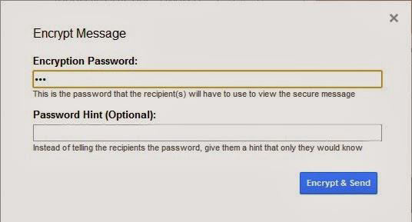

To decrypt the email, your recipient will also need the Secure Gmail extension installed, as well as the password.

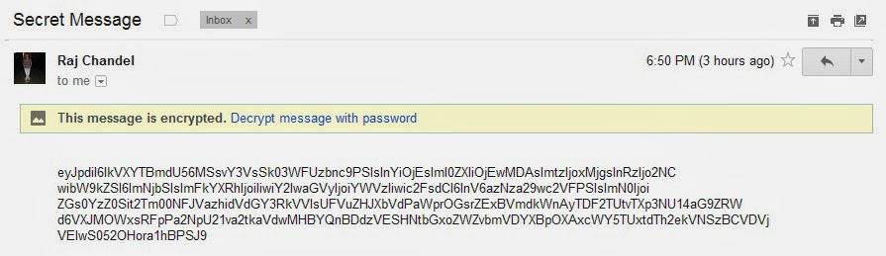

**You might also like:**

Send Future Mail through Gmail

Search Gmail emails without login Gmail

How to Undo Send Mail in Gmail

How to Hack Gmail Account

Read Gmail mail with Right Click

Hack Gmail Password using Hydra in kali Linux

Linkwithin

posted in **EMAIL HACKING** , **KALI LINUX** , **PENETRATION TESTING** on **JULY 4,**

**2013** by **RAJ CHANDEL** with **3 COMMENTS**

Open your Kali Linux terminal and Type **xhydra** and press enter



You can also do this manually. First Open Your Kali Linux and Follow this path

**Kali Linux->Passwords Attacks->Online Attacks->Hydra**

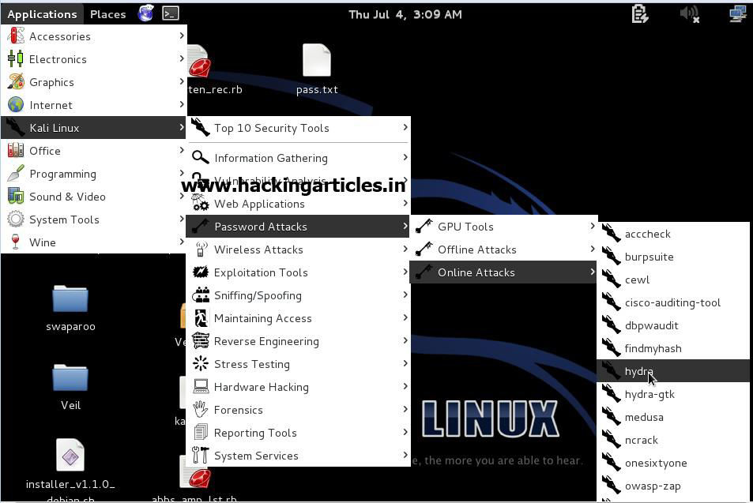

In the target tab, select

**Single Target**: smtp.gmail.com

**Protocol:** smtp

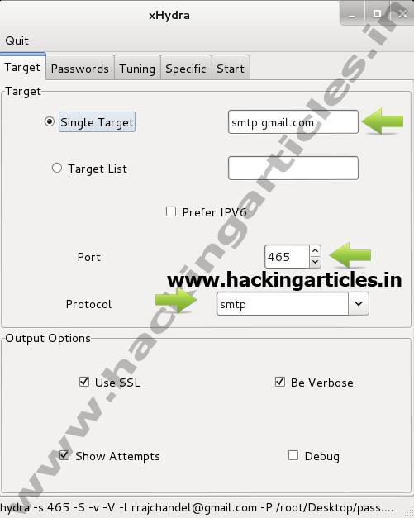

In passwords tab, select

**Username**: Type Victim Email ID

In the passwords, select the password list option and browse to select your

Passwords file. Here I have used my custom password file.

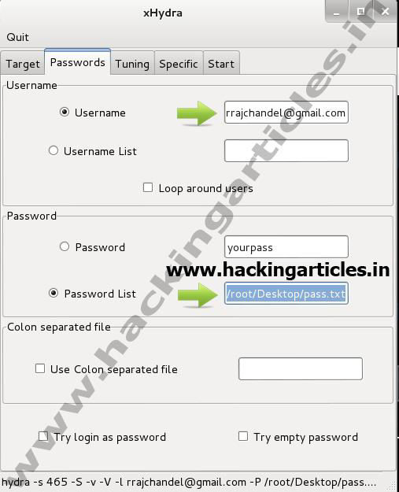

Now select start tab and click on **start** button, the password cracking begins and result is as follows

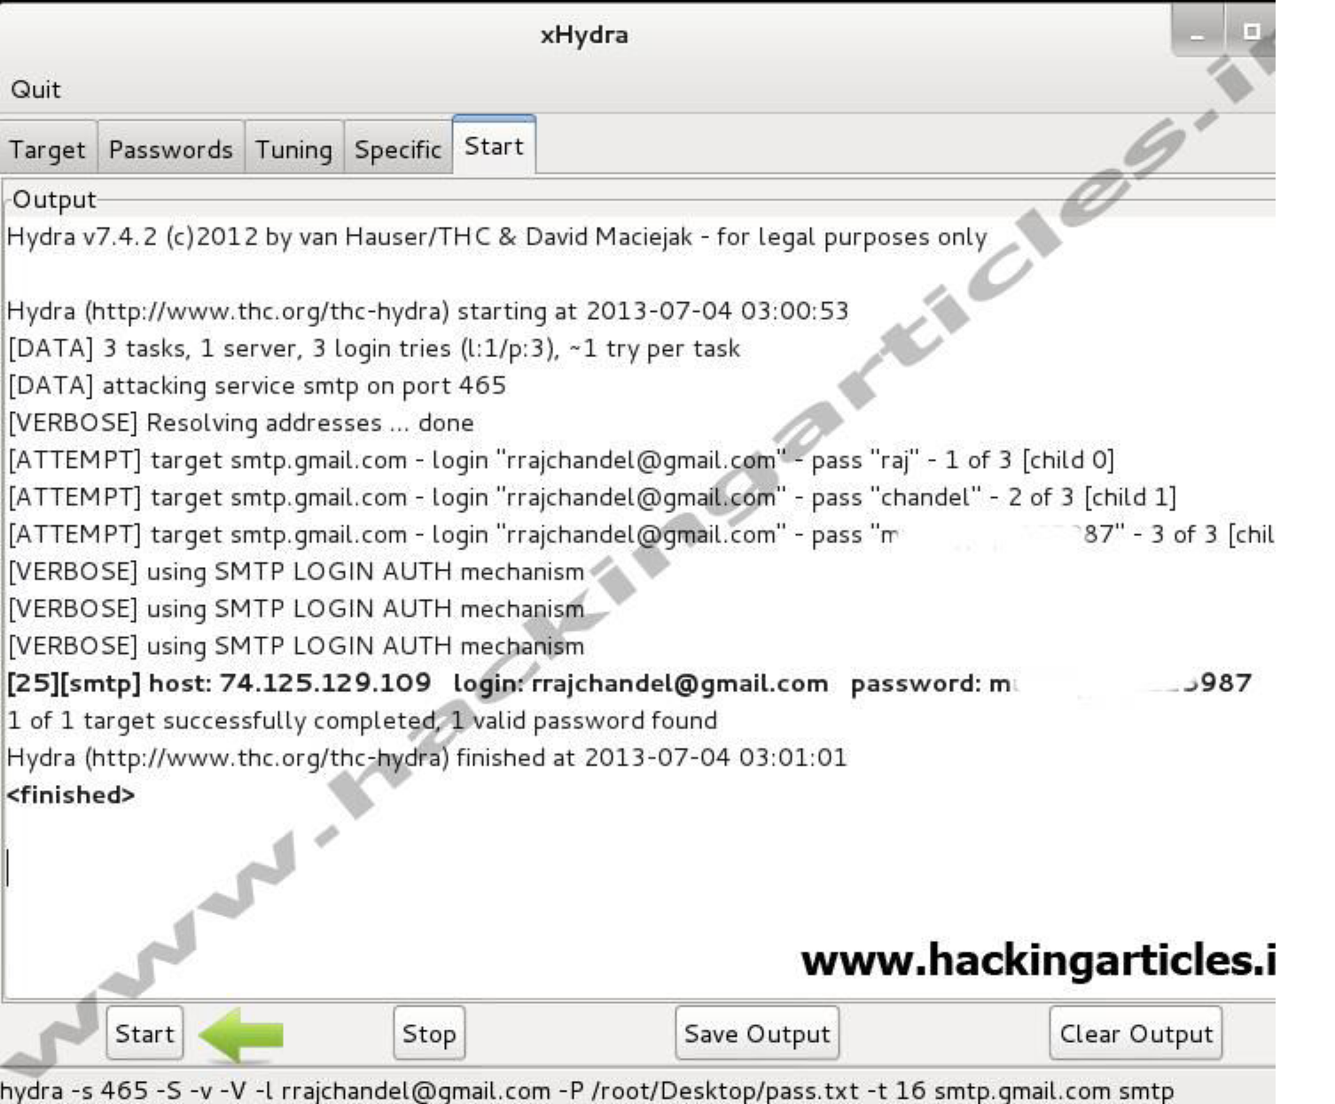

**You might also like:**